Culture Coordinating Committee

Agenda

DLNSEO Deputies Conference Room
3 February 2016 / 0830

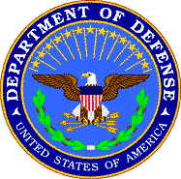

- Opening Remarks Dr Michael Nugent
Director, DLNSEO

- Overview Remarks Mr. Al Piotter
DLNSEO

- Introductions Attendees

- Program Updates Attendees

- Break

- Program Presentations Marc Hill
DLNSEO DLNSEO

- Lunch

- Program Presentations
Culture Testing, Measurement, and Assessment Dr Joel Koeth
DLNSEO
- Break

- Program Presentations
CBRIP/LRI Scott Brokaw
Joint Staff
LREC Dashboard Raoul Vicencio
DLNSEO
- Break

- Section 8, DoDI 5160.70 Marc Hill
DLNSEO
- Closing Remarks/Future Meetings Marc Hill
DLNSEO

