Culture Coordinating Committee

Agenda

DLNSEO Deputy Conference Room
4 August 2015 0830 - 1700

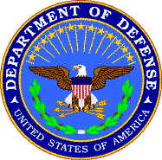

- Welcome/Introductions Marc Hill
DLNSEO

- Overview Remarks Mr. Al Piotter
DLNSEO

- Opening Remarks Dr. Michael Nugent
Director, DLNSEO

- Program Presentations*
AFCLC USAF
CAOCL USMC

- Break

- Program Presentations*
SOCOM Regional Studies SWEG (A)
CLREC USN

- Lunch

- Program Presentations*
TCC USA
SOCOM USAFSOS USAFSOS

- Break

- Discussion: Future Meetings Marc Hill
DLNSEO

- Closing Remarks Marc Hill
DLNSEO

